**AIRBNB Case Study Methodology**

|  |
| --- |
| **Introduction**  Airbnb, Inc. is an American company that operates an online marketplace for lodging, primarily homestays for vacation rentals, and tourism activities. Airbnb provides platform for hosts to accommodate guests with short-term lodging and tourism-related activities.  New York is the most diverse and populated in the United States. The city consists of 5 borrows: Manhattan, Brooklyn, Queens, the Bronx and Staten Island, all of which were “grouped” together into a single city. It is widely recognized as the global centre for the financial services industry. It is also the heartbeat of the American media, entertainment (along with California), telecommunications, and law and advertising industries.    **Business Objective:**  For the past few months, Airbnb has seen a major decline in revenue. Now that the restrictions have started lifting and people have started to travel more, Airbnb wants to make sure that it is fully prepared for this change. |

**Methodology Document PPT 1 :**

In the case study we have used Jupiter notebook to perform initial analysis of the data and Tableau for data analysis and visualization.

**Initial Analysis using Jupiter Notebook:** Data Set Used: AB_NYC.2019.csv

**Number of Rows:** 48895

**Number of Columns:** 16

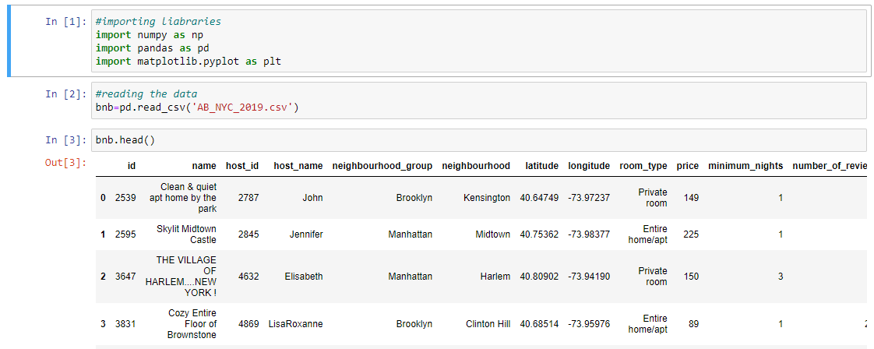

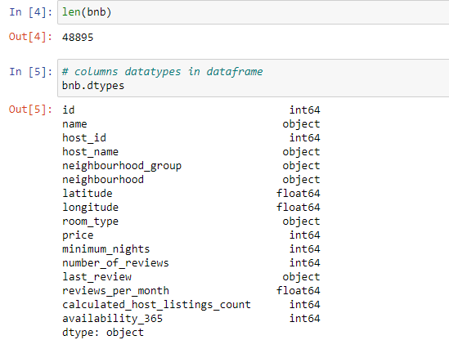

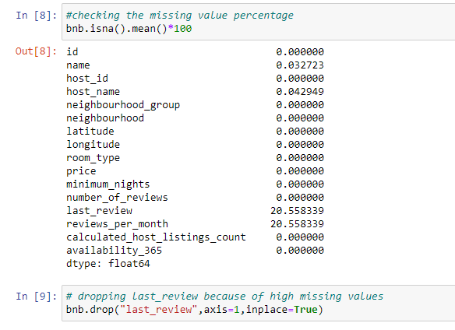

* We removed the columns ‘Last Review’ which was not giving much information and replacing the column reviews_per_month null values with ‘0’ because of no reviews.

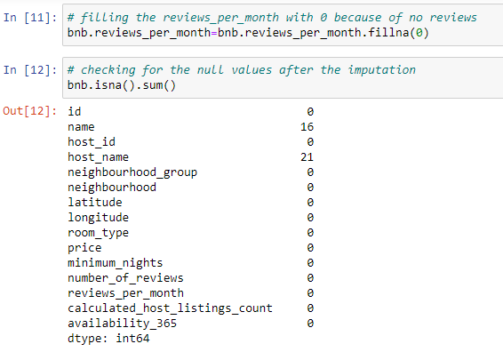

**Step 2: Data Wrangling**:

* Checked the Duplicate rows in our dataset and no duplicate data was found.
* Checked the Null Values in our dataset. Columns like name, host_name, last review and reviews_per_month have null values.
* We’ve dropped the column name as missing values are less and dropping it won’t have significant impact on analysis.
* Checked the formatting in our dataset.
* Identified and review outliers.

**Data Analysis and Visualizations using Tableau:**

We have used tableau to visualize the data for the assignment. Below are the detailed steps used for each visualization.

**Methodology Document PPT 1:**

1. **Top 10 Host :**

* We identified the top 10 Host Name with neighbourhood group and count of Host names using the bar chart.

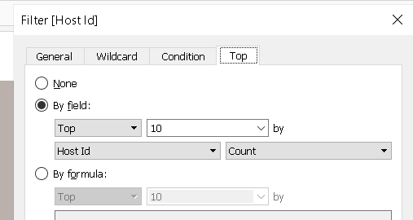

1. **Preferred Room type w.r.t count of host listings:**

* We created a pie chart for understanding the percentage of room type preferred wrt count host listing.
* We added Room Type to the colors Marks card to highlight the different Room Type in different colors and count of Host Id to the size

1. **Most valued customers:**

* we have created a bar chart for neighbourhood and host name with host listing count.

1. **Average price of room type per neighbourhood groups:**

• We created a stacked bar chart with Neighbourhood Groups in Columns and Price column in Rows.

•We added the room type to the colors Marks card to highlight the different room types in different colors. Also put Avg price in Label.

1. **Popular Neighborhoods:**

* We took neighbourhood in rows and sum of reviews in column and took neighbourhood groups in color.
* We used filter to show Top 20 neighbours as per the sum of reviews.

1. **Customer preference per night stay:**

We have created bar chart, most of the customer visit either for 1 day or 2 days. But there is strange trend for 30 days also.

**Methodology Document PPT 2 :**

1. **Average** **Price w.r.t Neighbourhood group:**

* We created a bubble chart for understanding the average price w r t neighbourhood group.
* We added Room Type to the colors Marks card to highlight the different room Type in different colors and count of Host Id to the size.

1. **Neighbourhood vs Availability:**

* We created a bar chart for availability 365 for different neighbourhood.

1. **Distribution of properties wrt different areas.**The density of properties is high in Manhattan compare to others areas.
2. **Price variation w r t Geography:**

* We used Geo location chart to plot neighbourhood, neighbourhood Group in map to show case the variation of prices across.

1. **Popular Neighborhoods:**

* We took neighbourhood in rows and sum of reviews in column and took neighbourhood groups in color.
* We used filter to show Top 20 neighbours as per the sum of reviews.

1. **Highest reviewed properties.**

* Bar chart has been created between properties with count of reviews.
* Neighbourhood group has been added for colors marks card.